CSIT314 Software Development Methodologies - Group Project

Sprint 2 - US17: Delete company profile
Interior Design Platform - Interior Designer
All diagrams were drawn in draw.io. Open "US17 Delete company profile.drawio" in this folder to edit them - each diagram is its own page in that file. The exported images are in the "diagrams" folder.

Assumptions
- The system is the Interior Design Platform from the project specification. Sprint 2 covers the Interior Designer's stories (log in, company profile and log out, US13 - US19) and the Platform Manager's log in (US39).
- We follow B-C-E: the actor only talks to the boundary (page), the boundary only talks to the controller, and the controller works with the entity classes. There is one controller per use case.
- Deleting removes the designer's row from the company_profile table (a real delete, not a hidden status). There is no undo. The designer can create a new profile afterwards with UC14.
- Only the company profile is deleted. The designer's user account is kept and they stay logged in.
- Clicking "Delete company profile" only opens a confirmation box - nothing is deleted until the designer confirms. The box names the company that will be deleted.
- When the box opens, the system remembers which company is being deleted (designerId, companyId and a random token in the session). The delete only goes through if all three match, and each confirmation can only be used once. So an old confirmation can't delete a newer profile.
- A designer can only use their own company profile. The owner always comes from the logged-in session, so a designerId or companyId put in the URL or the form is ignored. The delete must match both the owner and the companyId.
- A missing, wrong or used confirmation shows "Please open the delete confirmation and try again" (HTTP 400) and nothing is deleted.
- Every designer page checks access again from the database (InteriorDesignerLoginController.getAuthenticatedDesigner() from US13). Someone who is not logged in is sent to the designer login page. Anyone else without designer access (e.g. a User Admin, or a designer suspended after logging in) gets "Access unavailable" (HTTP 403).

1. User story
Story ID | US17
User story | As an interior designer, I want to delete my company profile so that it is no longer shown on the platform.
Actor | Interior Designer
Priority | Medium
Story points (estimate) | 3
Acceptance criteria | 1. Given I am viewing my company profile, there is a "Delete company profile" button.  2. Given I click it, then a box asks "Are you sure you want to delete <company name>?" and nothing is deleted yet.  3. Given I click "Delete company profile" in the box, then the profile is deleted, I go to the dashboard and see "Company profile deleted successfully", and the dashboard shows "Create company profile" again.  4. Given I click "Cancel" in the box, then I go back to my company profile and nothing is deleted.  5. My user account is not deleted and I stay logged in.  6. Given the confirmation is missing, old or has been changed, then I see "Please open the delete confirmation and try again" and nothing is deleted.
Tasks | T17.1 Write the use case description and draw the use case diagram  T17.2 Draw the B-C-E class diagram and the sequence diagram  T17.3 Draw the wireframes for the delete button, the confirmation box, the success message, profile not found and the confirmation error  T17.4 Write the unit tests first (TDD) for CompanyProfile.deleteCompanyProfile(), DeleteCompanyProfileController and DeleteCompanyProfilePage  T17.5 Code CompanyProfile.deleteCompanyProfile() (owner and companyId must both match)  T17.6 Code DeleteCompanyProfileController  T17.7 Code DeleteCompanyProfilePage with the confirmation box and the one-time confirmation token  T17.8 Add the "Delete company profile" button to the view page  T17.9 Run the test cases, fix bugs and push to the repo so the CI pipeline runs the unit tests

2. Use case diagram
The user story becomes one use case, UC17 Delete company profile. The Interior Designer is the only actor.
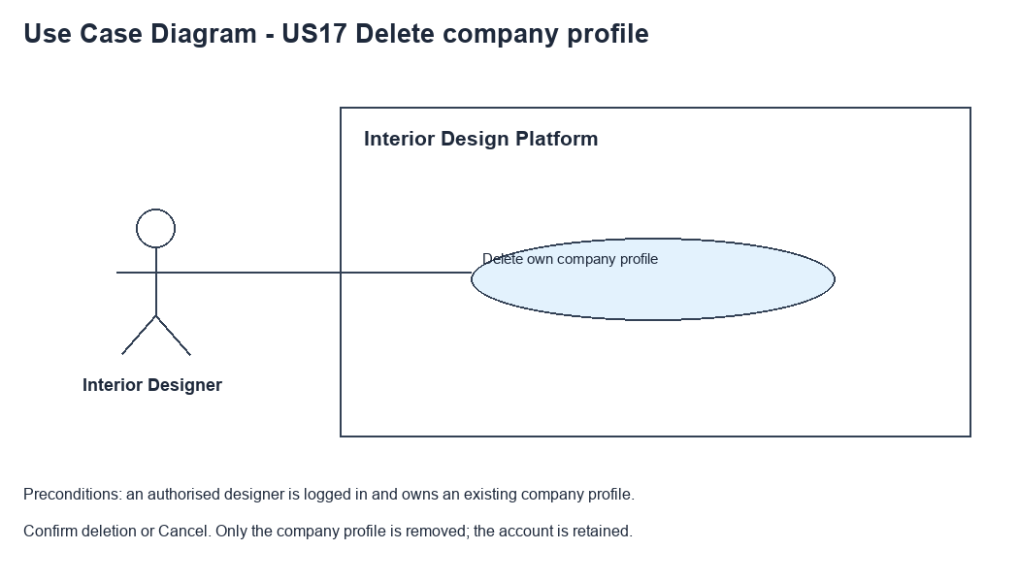
Figure 1: Use case diagram for US17 Delete company profile

3. Use case description
Use case | UC17 Delete company profile
Actor | Interior Designer
Brief description | The Interior Designer deletes their company profile so it is no longer shown on the platform.
User story | US17: As an interior designer, I want to delete my company profile so that it is no longer shown on the platform.
Preconditions | The Interior Designer is logged in (UC13).  The designer has a company profile (UC14).
Trigger | The Interior Designer clicks "Delete company profile" on the company profile page (UC15).
Basic flow | 1. The Interior Designer clicks "Delete company profile".  2. The system checks the designer's access and loads their company profile.  3. The system shows a confirmation box naming the company, and remembers which company is being confirmed.  4. The Interior Designer clicks "Delete company profile" in the box.  5. The system checks the access again and checks the confirmation (same designer, same company, same token).  6. The system deletes the company profile.  7. The system shows the designer dashboard with "Company profile deleted successfully".
Alternative flows | 2a. The designer has no company profile: the system shows "You have not created a company profile yet" (HTTP 404). The use case ends.  4a. The Interior Designer clicks "Cancel": the system closes the box and goes back to the company profile. Nothing is deleted.  5a. The confirmation is missing, wrong or already used: the system shows "Please open the delete confirmation and try again" (HTTP 400). Nothing is deleted.  6a. The profile is already gone: the system shows "You have not created a company profile yet". If the delete fails while a profile still exists, the system shows "Company profile could not be deleted. Please reopen the confirmation".
Postconditions | The company profile is deleted. The user account is kept and the designer is still logged in.  The dashboard shows "Create company profile" again.

4. Wireframes
The wireframes were drawn in draw.io. They are low-fidelity: they show the layout and the flow, not the final colours. The orange numbers match the notes under each screen.

4a - Delete button
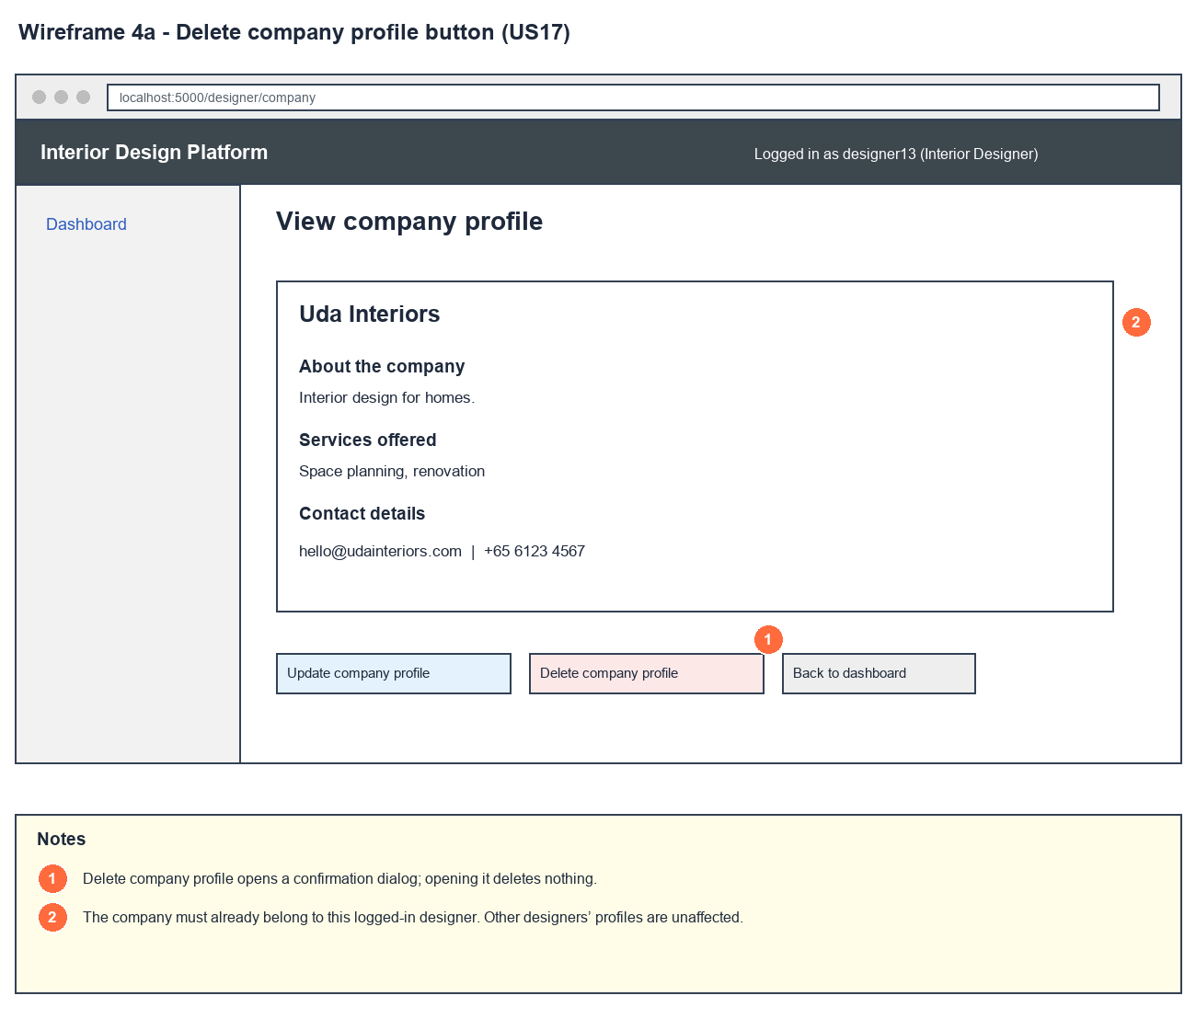
Figure 2: Wireframe 4a - Delete button (US17)

4b - Confirm delete
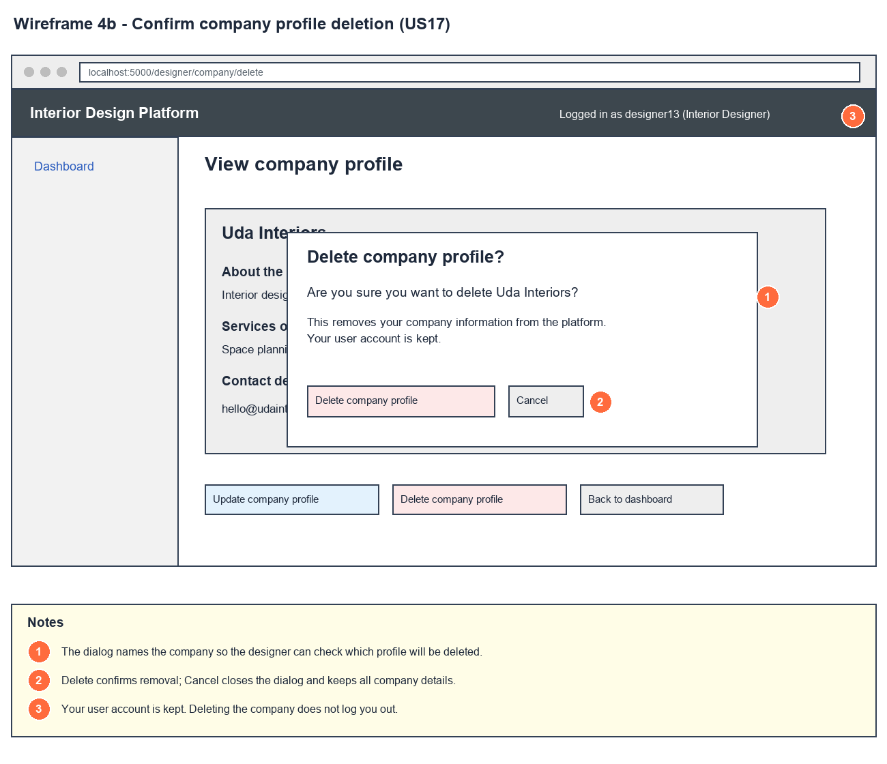
Figure 3: Wireframe 4b - Confirm delete (US17)

4c - Company deleted
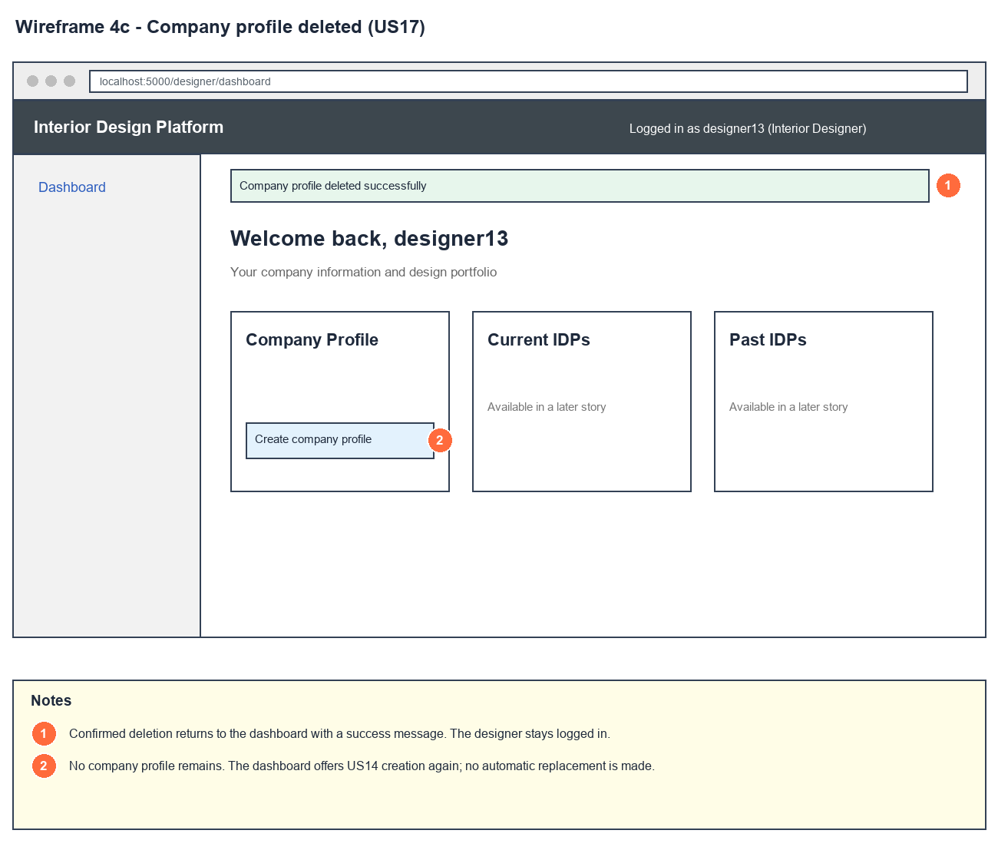
Figure 4: Wireframe 4c - Company deleted (US17)

4d - Profile not found
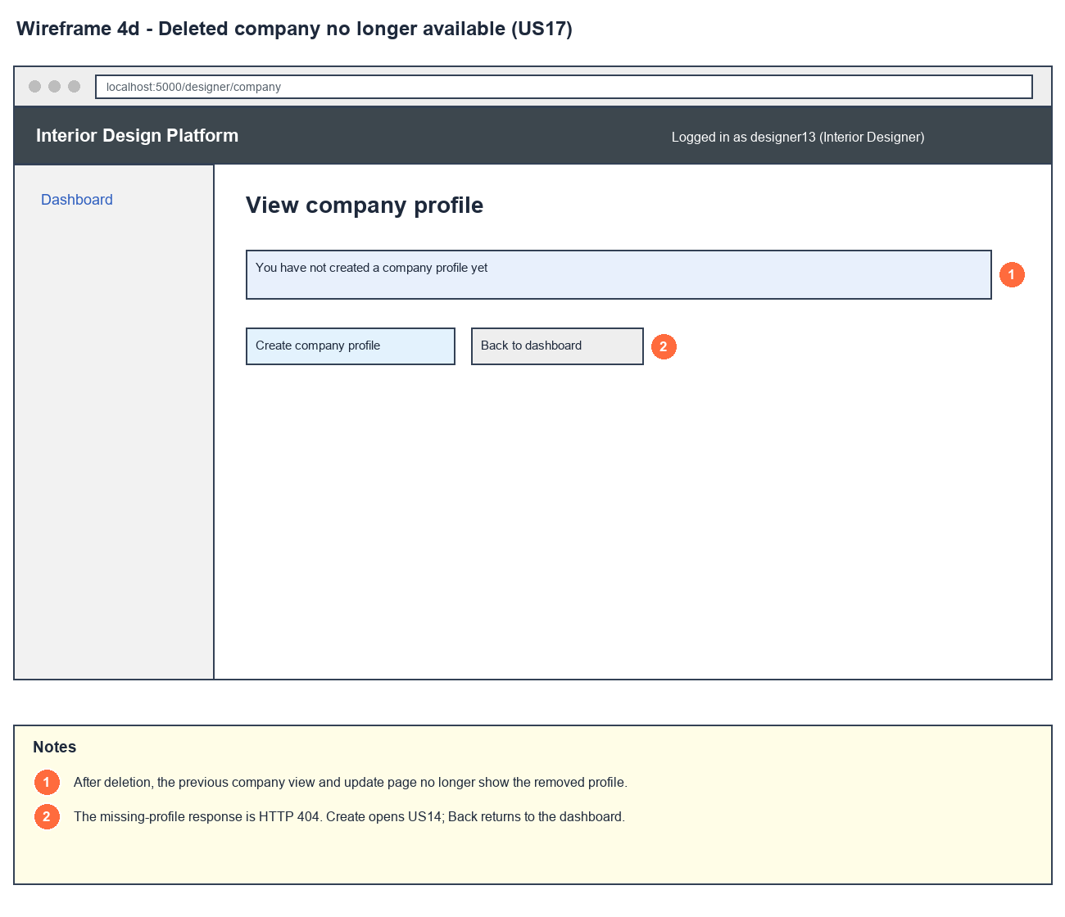
Figure 5: Wireframe 4d - Profile not found (US17)

4e - Confirmation error
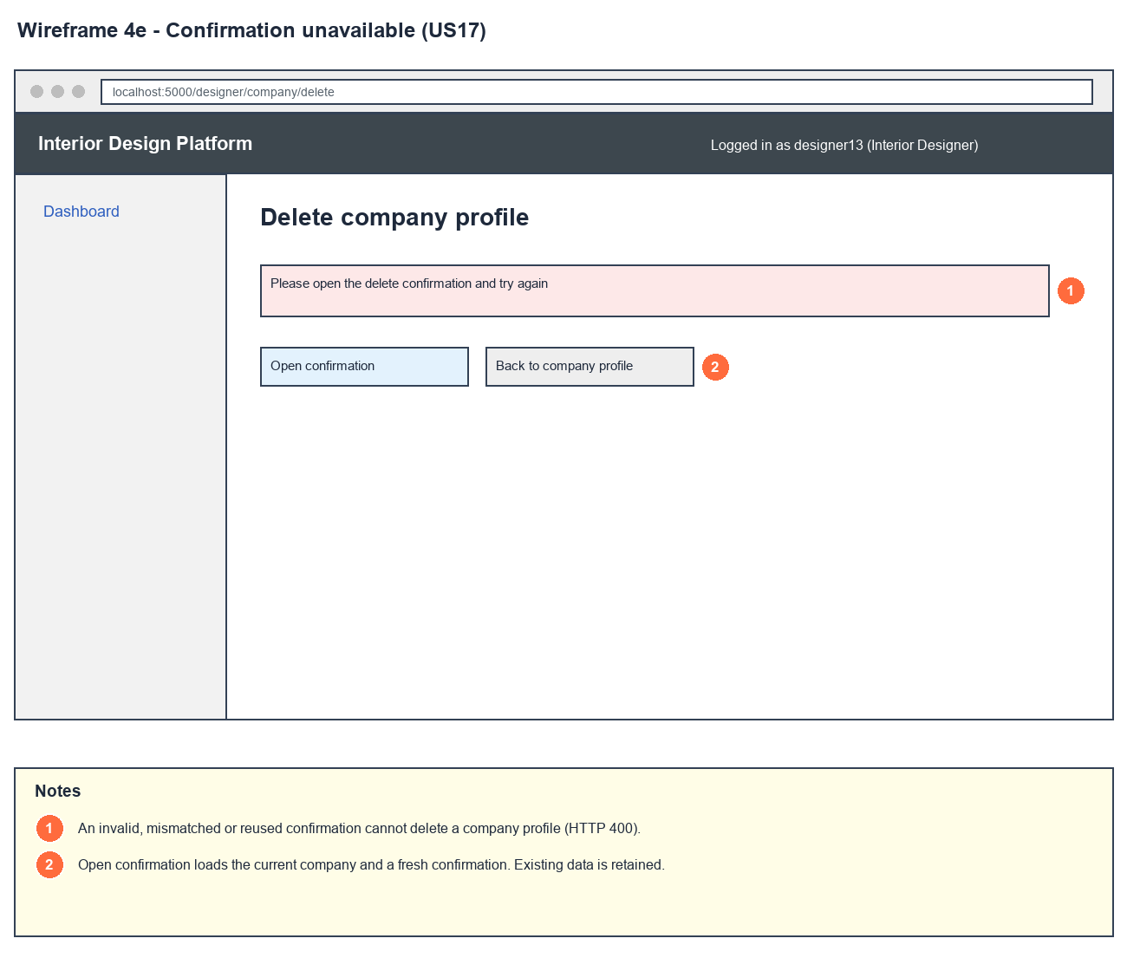
Figure 6: Wireframe 4e - Confirmation error (US17)

5. B-C-E class diagram
The solid line means the boundary calls the controller. The dashed lines mean the controller uses the other classes. Only the operations needed for this use case are shown.
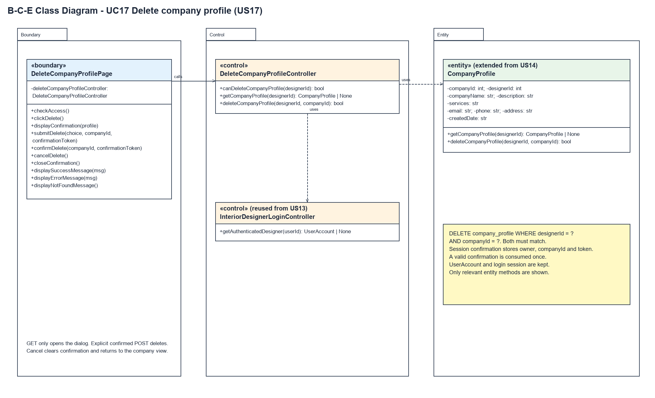
Figure 7: B-C-E class diagram for US17 Delete company profile
Layer | Class | What it does
Boundary | DeleteCompanyProfilePage | The delete confirmation. clickDelete() checks access and opens the box (displayConfirmation), saving the designerId, companyId and a random token in the session. submitDelete() sends Cancel to cancelDelete() and Delete to confirmDelete(), which checks and uses up the confirmation before asking the controller to delete.
Control | DeleteCompanyProfileController | Controller for UC17. canDeleteCompanyProfile() checks access, getCompanyProfile() loads the profile and deleteCompanyProfile() checks access again before asking CompanyProfile to delete.
Control | InteriorDesignerLoginController (from US13) | getAuthenticatedDesigner() checks the account and profile are Active and have the designer permissions.
Entity | CompanyProfile | Extended from US14 with deleteCompanyProfile(designerId, companyId), which deletes the row only if both the owner and the companyId match.

6. Sequence diagram
The sequence diagram follows UC17. The page checks access (step 2) and loads the profile. The outer alt shows the not-found page (alternative flow 2a) or opens the confirmation box (step 3), which saves the confirmation in the session. When the designer answers, the page checks access again. The next alt splits Cancel (alternative flow 4a) from Delete. For Delete, the inner alt rejects a missing or wrong confirmation (alternative flow 5a). Otherwise the confirmation is used up and the controller deletes the matching row (step 6). The last alt shows the success message (step 7) or the not-found / could-not-be-deleted message (alternative flow 6a).
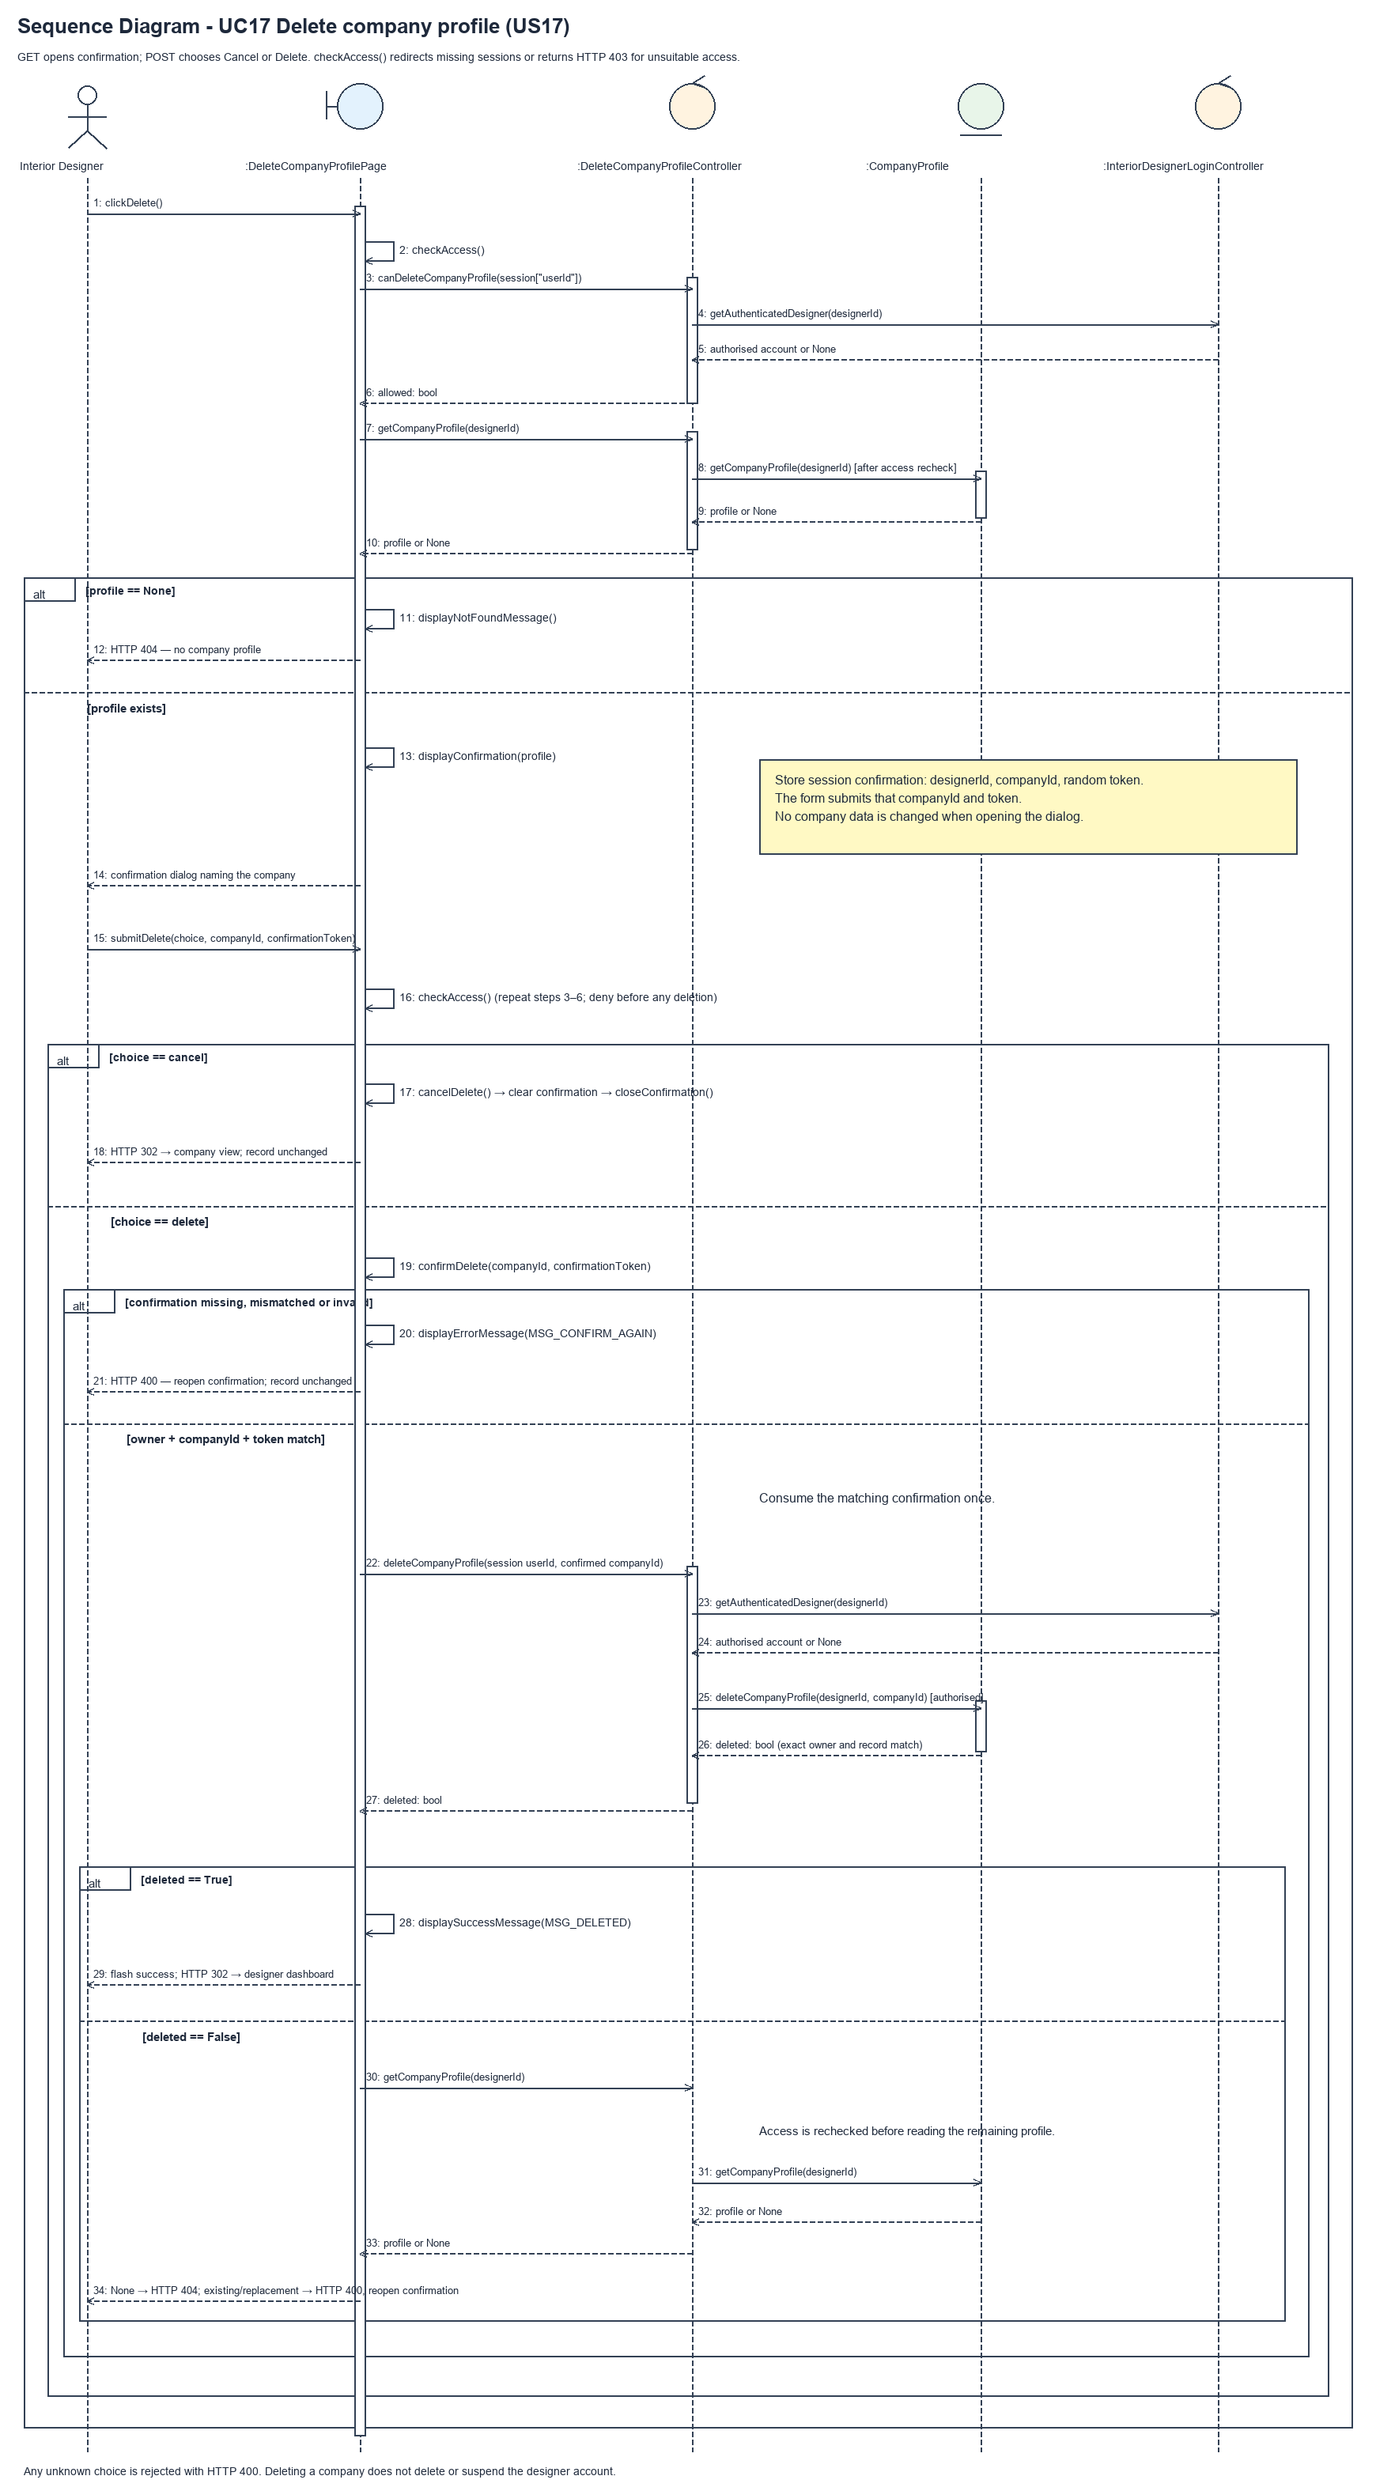
Figure 8: Sequence diagram for UC17 Delete company profile

7. Test cases
Test data used below (same as database/seedData.py and the test files): user profiles User Admin (id 1), Interior Designer (id 2), Customer (id 3) and Platform Manager (id 4), all Active. User accounts admin01 / Admin@123 (User Admin) and cust001 / Cust@123 (Customer). The designer account designer13 / Design@123 (Tengku Uda Designer, Interior Designer profile) is made first with UC8. Company data: Uda Interiors, "Interior design for homes.", "Space planning, renovation", hello@udainteriors.com, +65 6123 4567, 10 Design Street. designer13 already has this company profile.

7a. System test cases (black box)
Equivalence partitioning and boundary value analysis were used to pick the test data. Fill in "Actual result" and "Pass/Fail" after running each test.
Test ID | Scenario | Prerequisites | Test steps | Test data | Expected result | Actual result | Pass / Fail
TC17.1 | Delete the company profile | Logged in as designer13. Has a company profile. | 1. Open the company profile  2. Click "Delete company profile"  3. Click "Delete company profile" in the box | - | "Company profile deleted successfully" on the dashboard. The dashboard shows "Create company profile".
TC17.2 | Confirmation box doesn't delete | Logged in as designer13. Has a company profile. | 1. Click "Delete company profile" | - | The box says "Are you sure you want to delete Uda Interiors?". The profile still exists.
TC17.3 | Cancel | Logged in as designer13. Has a company profile. | 1. Click "Delete company profile"  2. Click "Cancel" | - | Back on the company profile. Nothing deleted.
TC17.4 | Account is kept | TC17.1 done. | 1. Open the dashboard  2. Log out and log in again | designer13 / Design@123 | Still logged in after deleting, and can log in again normally.
TC17.5 | Deleted profile can't be viewed | TC17.1 done. | 1. Open /designer/company | - | "You have not created a company profile yet".
TC17.6 | Old confirmation used again | TC17.1 done using the confirmation box. | 1. Send the same confirmation again (e.g. browser back and resubmit) | Old token | "Please open the delete confirmation and try again" (HTTP 400).
TC17.7 | No company profile | Logged in as designer13. No company profile. | 1. Open /designer/company/delete | - | "You have not created a company profile yet" (HTTP 404).
TC17.8 | User Admin can't delete | Logged in as admin01. designer13 has a profile. | 1. Open /designer/company/delete | - | "Access unavailable" (HTTP 403). Nothing deleted.

7b. Unit test cases (for TDD)
These are written before the code (test-driven development) and run automatically in the CI pipeline. They cover normal inputs, abnormal inputs and boundary values. Each one matches a test function in tests/test_us17_deleteCompanyProfile.py (e.g. UT17.1 is test_ut17_1_...). Pass / Fail is from the pytest run on 23 October 2026.
Test ID | Class and method | Input / setup | Expected output | Type | Pass / Fail
UT17.1 | DeleteCompanyProfileController.deleteCompanyProfile() | designer13, their companyId | Returns true. No company profiles left | Normal | Pass
UT17.2 | DeleteCompanyProfileController.deleteCompanyProfile() | designer13 with no profile, companyId 9999 | Returns false | Abnormal | Pass
UT17.3 | DeleteCompanyProfileController.deleteCompanyProfile() | userId 1 (User Admin), designer13's companyId | Returns false. Profile kept | Abnormal | Pass
UT17.4 | DeleteCompanyProfileController.deleteCompanyProfile() | designer13, companyId 9999 | Returns false. Profile kept | Abnormal | Pass
UT17.5 | DeleteCompanyProfileController.deleteCompanyProfile() | designer13 with the account suspended | Returns false. Profile kept | Abnormal | Pass
UT17.6 | DeleteCompanyProfileController.deleteCompanyProfile() | designer13, their companyId | Account still Active and designer13 can still log in | Normal | Pass
UT17.7 | CompanyProfile.deleteCompanyProfile() | designer17's id with designer13's companyId, then designer13's | False, then true. designer17's profile kept | Abnormal | Pass
UT17.8 | CompanyProfile.deleteCompanyProfile() | Same delete twice | True, then false | Boundary | Pass
UT17.9 | CompanyProfile.deleteCompanyProfile() | Old companyId after a new profile was made | Returns false. New profile kept | Abnormal | Pass
UT17.10 | View company profile page | designer13 with a profile | Has the "Delete company profile" link | Normal | Pass
UT17.11 | DeleteCompanyProfilePage.clickDelete() | GET /designer/company/delete | "Are you sure", the company name and a confirmation token. Nothing deleted | Normal | Pass
UT17.12 | DeleteCompanyProfilePage.confirmDelete() | POST choice=delete with the right companyId and token | "Company profile deleted successfully" and a create link. Profile gone | Normal | Pass
UT17.13 | DeleteCompanyProfilePage.cancelDelete() | POST choice=cancel | Redirects to /designer/company. Profile kept. Confirmation cleared | Normal | Pass
UT17.14 | DeleteCompanyProfilePage.checkAccess() | Not logged in (GET and POST) | Redirects to /designer/login | Abnormal | Pass
UT17.15 | DeleteCompanyProfilePage.checkAccess() | Logged in as admin01 (GET and POST) | HTTP 403. Profile kept | Abnormal | Pass
UT17.16 | DeleteCompanyProfilePage.displayNotFoundMessage() | designer13 with no profile | HTTP 404 and "You have not created a company profile yet" | Abnormal | Pass
UT17.17 | DeleteCompanyProfilePage.confirmDelete() | POST without opening the box first | HTTP 400. Profile kept | Abnormal | Pass
UT17.18 | DeleteCompanyProfilePage.confirmDelete() | confirmationToken = "wrong-token" | HTTP 400. Profile kept | Abnormal | Pass
UT17.19 | DeleteCompanyProfilePage.confirmDelete() | companyId changed to 9999 | HTTP 400. Profile kept | Abnormal | Pass
UT17.20 | DeleteCompanyProfilePage.confirmDelete() | Form and URL include designer17's designerId | Only designer13's profile is deleted | Abnormal | Pass
UT17.21 | DeleteCompanyProfilePage.checkAccess() | Profile suspended after opening the box | HTTP 403. Profile kept | Abnormal | Pass
UT17.22 | DeleteCompanyProfilePage.confirmDelete() | Valid delete | Still logged in, confirmation cleared, dashboard opens | Normal | Pass
UT17.23 | View / update after deleting | Valid delete, then open view and update | Both give HTTP 404 | Normal | Pass
UT17.24 | DeleteCompanyProfilePage.confirmDelete() | Same confirmation sent twice | Second one gives HTTP 400 | Abnormal | Pass
UT17.25 | DeleteCompanyProfilePage.confirmDelete() | Old confirmation after the profile was replaced | HTTP 400. New profile kept | Abnormal | Pass
UT17.26 | DeleteCompanyProfilePage.submitDelete() | choice = "unknown" | HTTP 400. Profile kept | Abnormal | Pass
UT17.27 | DeleteCompanyProfilePage.displayConfirmation() | companyName = "<script>alert(1)</script>" | Shown escaped, not run | Abnormal | Pass
UT17.28 | Create, view, update then delete | Whole flow through the pages | No profiles left, view gives 404, dashboard shows the create link | Normal | Pass

